Algebra 1: Unit 1, Lesson 2

- Given that $h\left(x\right)=x^{3}-2$, what is the value of $h(-1)$?

$$-3$$

- Given the equation $y=-\frac{1}{4}x+3.5$, what is the value of $y$ when $x=8$?

1.5

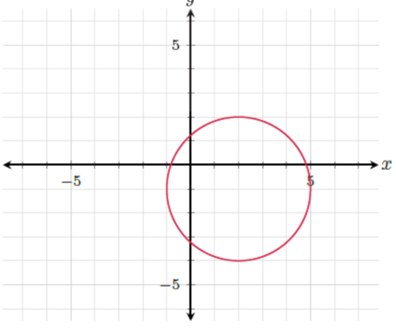

- Is the shown relation a function or not a function?

Not a function

